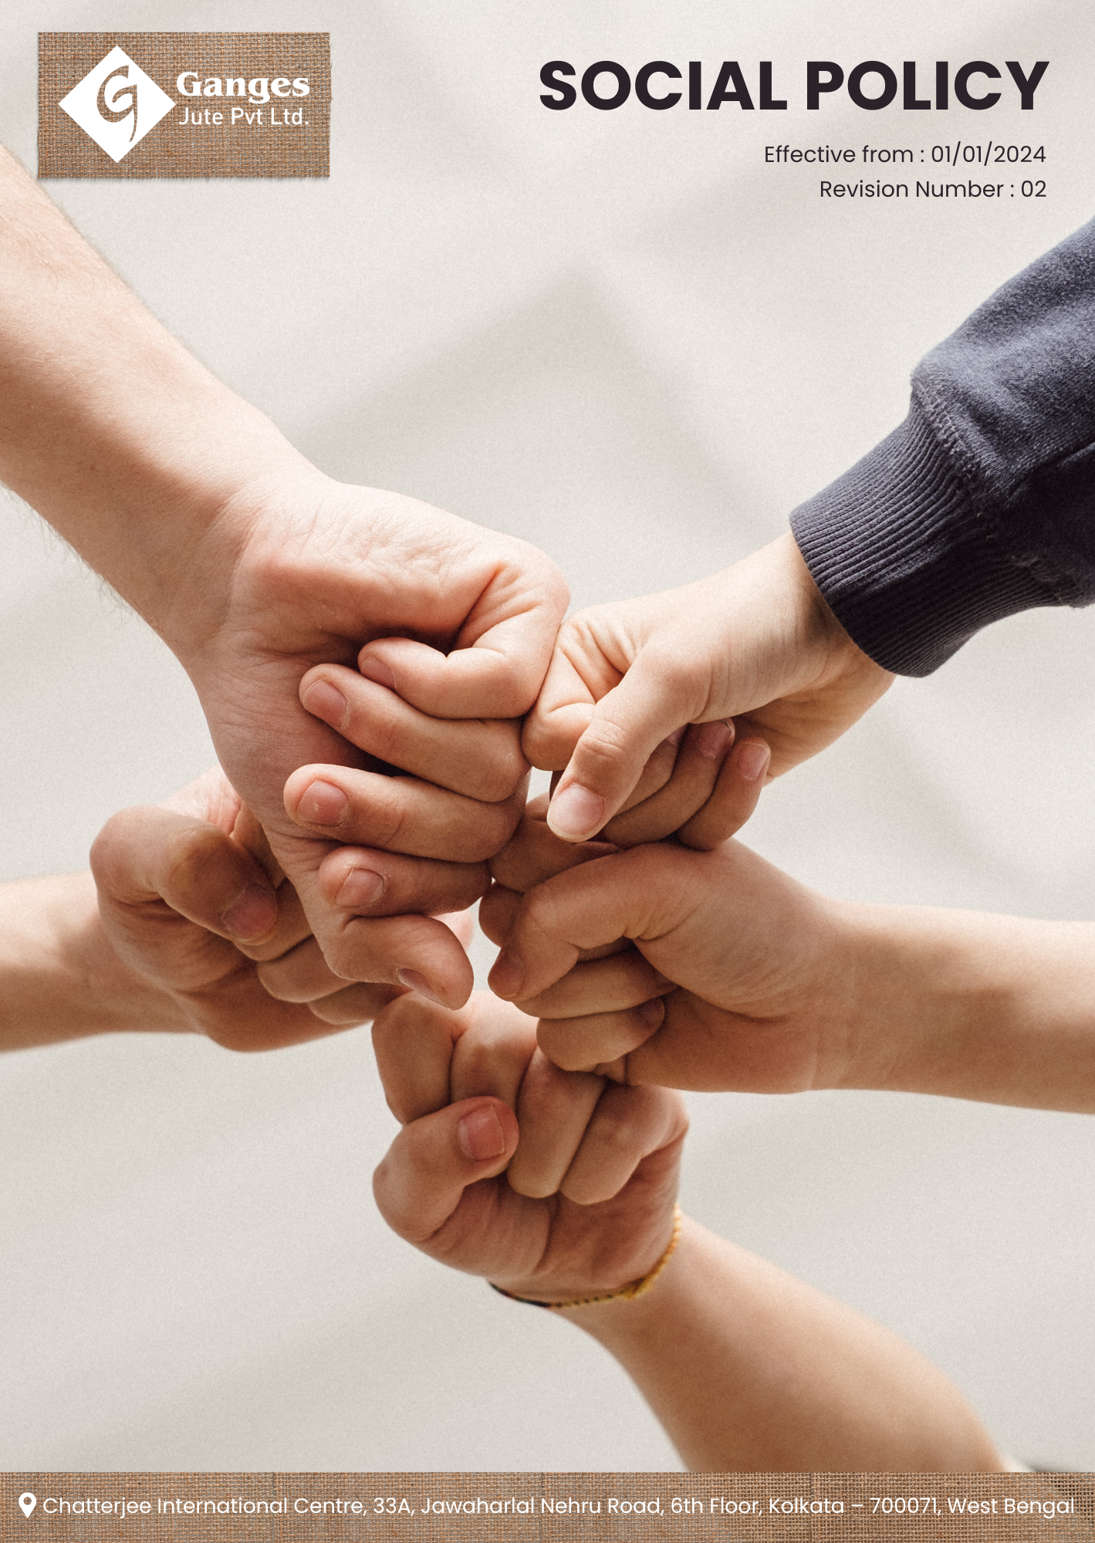

Table Of Contents

1. Why It Matters 3
2. The Ganges Jute Way 3
3. Scope 3
4. What's Expected 3
5. Jute's Journey to Social Responsibility: A Ganges Jute Commitment 4
6. Responsibility 6
7. Reporting Section 7
8. Covered SDGs 8
9. Review Mechanism 8
10. Employee Acknowledgement Form: Social Policy 10

Why It Matters
Ganges Jute Pvt Ltd is committed to fostering a socially responsible business environment, promoting ethical practices, and extending our people-centric mindset across the entire supply chain. This commitment is not only an important social responsibility but also creates value for our business, customers, stakeholders, employees, and the communities we serve.

The Ganges Jute Way
It is the policy of Ganges Jute Pvt Ltd to design, manufacture, and deliver our jute products and to operate our business in a way that respects human rights, promotes worker welfare, and contributes positively to society. This includes ensuring safe working conditions, fair labor practices, community development, and ethical business conduct, while extending our social responsibility mindset across the value chain.

We set annual goals, develop necessary capabilities, and commit appropriate resources to achieve this policy through innovation, operational excellence, and aligning Ganges Jute's supply chain with this policy.

Scope
This policy applies to all employees, stakeholders, contractors, partners, customers, contractual workers, and anyone acting on behalf of following sites:

 | Ganges Jute Pvt Ltd
 | Address: Bansberia, Hooghly District, West Bengal, India
 | https://gangesjute.com/

What's Expected
- Social Compliance
Ganges Jute Pvt Ltd is dedicated to upholding the highest social standards in our operations. We comply with all relevant social laws and regulations while fostering a culture of employee engagement and community support. By setting performance standards and utilizing a comprehensive Social Management System, we drive compliance and continuous improvement in areas such as workplace safety, human rights, and community impact, including through:
- Ensuring that all employees work in safe, healthy, and respectful conditions, complying with all relevant labor laws and standards;
- Prioritizing the health and safety of our employees through comprehensive EHS policies, regular training, and thorough risk assessments;
- Actively supporting community development by engaging in local projects, providing employment opportunities, and forming strategic partnerships;
- Focusing our CSR initiatives on sustainable development, education, healthcare, and environmental conservation to make a positive societal impact;
- Strictly prohibiting the use of child and forced labor, ensuring adherence to all relevant laws and regulations;
- Upholding the highest standards of human rights, ensuring non-discrimination and fair treatment for all employees and stakeholders;
- Committing to continuous learning and development by providing training programs and career growth opportunities for our employees;
- Respecting the right of employees to freely associate, form, and join organizations of their choice without fear of reprisal;
- Promoting open and constructive social dialogue between management and employees to ensure effective communication and cooperation;
- Fostering a diverse, equitable, and inclusive workplace by implementing policies to prevent discrimination and promote equal opportunities;
- Ensuring fair and competitive wages that meet or exceed local living wage standards;
- Prioritizing the well-being of our employees by providing mental health support, promoting work-life balance, and offering access to wellness programs

Jute's Journey to Social Responsibility: A Ganges Jute Commitment
- Establishes 2022 as the Baseline year for measuring progress and achievements in our sustainability initiatives.

- Workplace Safety and Health:
- We aim to achieve a 75% reduction in workplace accidents and a 50% decrease in occupational health issues by 2030, through the implementation of an AI-powered safety monitoring system and a comprehensive health and wellness program.
- We plan to obtain ISO 45001 certification for all our manufacturing facilities by 2030, ensuring world-class occupational health and safety management systems.
- We intend to implement a real-time ergonomic assessment system for 100% of workstations by 2030, reducing musculoskeletal disorders by 50%.

- Employee Well-being and Work-Life Balance:
- We aim to achieve an employee satisfaction rate of 90% regarding work-life balance by 2030, through the introduction of flexible working hours for 20% of our workforce and implementation of a comprehensive mental health support program.
- We plan to reduce employee turnover by 40% by 2030, through the introduction of personalized career development plans and a robust employee recognition program.

- Community Engagement and Development:
- We aim to positively impact 100,000 lives in our local communities by 2030, through targeted education, healthcare, and livelihood programs, investing 2% of our annual profits into these initiatives.
- We intend to support 1,000 women entrepreneurs in jute-based crafts by 2030, providing training, micro-financing, and market linkages to promote economic empowerment.

- Corporate Social Impact:
- We aim to achieve 100% traceability in our jute supply chain by 2030, ensuring fair wages and ethical working conditions for all farmers and workers involved.
- We plan to invest in 5 large-scale community infrastructure projects by 2030, including schools, healthcare facilities, and clean water systems, benefiting 20,000 people.
- We intend to launch a "Jute for Good" campaign by 2030, collaborating with 5 NGOs to promote sustainable jute products and raise awareness about social and environmental issues.

- Prevention of Child Labor:
- We aim to implement a comprehensive child labor prevention program across our entire supply chain by 2030, including rigorous age verification processes and regular third-party audits.
- We plan to support the education of 1,000 children in jute farming communities by 2030, through scholarships, school infrastructure improvements, and after-school programs.
- We intend to establish a child labor rehabilitation center by 2030, providing education and vocational training to 100 former child workers and their families.

- Elimination of Forced Labor:
- We aim to achieve 100% compliance with international forced labor standards across our operations and supply chain by 2030, through rigorous audits and a zero-tolerance policy.
- We plan to implement a worker voice platform by 2030, allowing anonymous reporting of labor violations, with a target of addressing 100% of valid concerns within 30 days.
- We intend to train 1,000 suppliers on forced labor prevention by 2030, with a goal of 100% of our tier 1 suppliers signing our Ethical Labor Pledge.

- Human Rights Protection:
- We aim to conduct human rights impact assessments for 100% of our operations and key suppliers by 2030, addressing all identified risks with concrete action plans.
- We plan to train 100% of our employees on human rights by 2030, with an advanced program for managers and key decision-makers.

- Employee Growth and Development:
- We aim to provide an average of 40 hours of training per employee annually by 2030, covering both technical skills and soft skills development.
- We plan to implement a leadership development program by 2030, with the goal of filling 40% of senior positions through internal promotions.

- Collective Bargaining and Worker Representation:
- We aim to ensure 100% of our workforce is covered by collective bargaining agreements by 2030, promoting fair and transparent labor relations.
- We plan to establish worker councils in all our facilities by 2030, ensuring regular dialogue between management and employee representatives.
- We intend to achieve a 95% resolution rate for worker grievances within 30 days by 2030, through an improved grievance mechanism and dedicated response team.

- Stakeholder Engagement:
- We aim to conduct annual stakeholder engagement surveys starting 2023, with a goal of achieving an 75% satisfaction rate regarding our social and environmental initiatives by 2030.
- We plan to establish a multi-stakeholder advisory panel by 2030, meeting quarterly to provide input on our sustainability strategy and performance.
- We intend to host an annual "Jute Sustainability Forum" starting 2030, bringing together industry peers, NGOs, and government representatives to address key social and environmental challenges.

- Diversity, Equity, and Inclusion:
- We aim to achieve 10% women representation in senior management roles by 2030, supported by targeted mentorship and leadership development programs.
- We plan to implement a comprehensive DEI training program for all employees by 2030, with 100% participation and a 90% effectiveness rating.
- We intend to achieve pay equity across all levels and demographics by 2030, conducting annual pay audits and making necessary adjustments.

Responsibility
- Board of Directors:
- Oversees the overall social responsibility strategy and approves long-term social impact goals.
- Ensures alignment of social initiatives with business objectives and stakeholder expectations.

- Chief Social Responsibility Officer (CSRO):
- Leads the development and implementation of the Social Policy across the organization.
- Reports directly to the CEO and provides regular updates to the Board of Directors.

- Senior Management:
- Provides leadership in implementing the Social Policy within their respective divisions.
- Allocates necessary resources and integrates social responsibility metrics into performance evaluations.

- Social Responsibility Committee:
- A dedicated committee comprising representatives from various departments is established to oversee the execution of social responsibility initiatives.
- The committee is tasked with developing action plans, monitoring performance, and recommending improvements to meet social objectives.

- Departmental Heads:
- Responsible for integrating social responsibility practices into their respective areas of operation.
- Ensure compliance with labor laws, promote employee well-being, and support community engagement efforts.

- Human Resources Manager:
- Ensures fair labor practices, oversees employee development programs, and manages diversity and inclusion initiatives.
- Conducts regular employee satisfaction surveys and implements improvement measures.

- Employees:
- All employees are encouraged to actively participate in social responsibility initiatives.
- They are expected to adhere to ethical practices, report any social concerns, and contribute ideas for continuous improvement.

Reporting Section
- Internal Reporting:
- Annual Social Responsibility Dashboard:
- The CSRO presents a comprehensive social responsibility dashboard to senior management and the Board.
- The dashboard highlights progress towards annual targets, emerging trends, and areas needing attention.

- Social Incident Reporting:
- A dedicated system for employees to report social incidents or concerns.
- The Human Resources Manager investigates all reports and implements corrective actions.

- External Reporting:
- External reporting is conducted annually to communicate our social performance to stakeholders, including customers, investors, and regulatory bodies.
- Reports are prepared in accordance with internationally recognized standards such as the Global Reporting Initiative (GRI) guidelines or UN Global Compact Communication on Progress.

- Stakeholder Engagement:
- We actively engage with stakeholders to gather feedback, address concerns, and foster transparency in our social responsibility practices.
- Stakeholder input is considered in decision-making processes and incorporated into social initiatives where applicable.

Covered SDGs
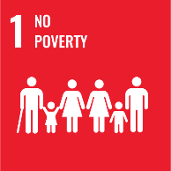 |  | 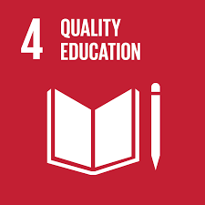 | 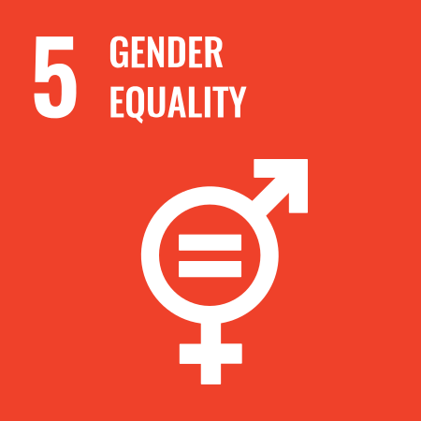 | 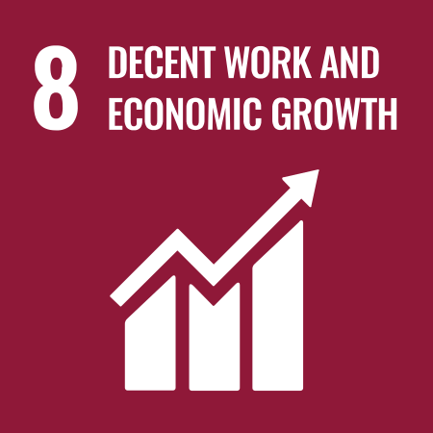 | 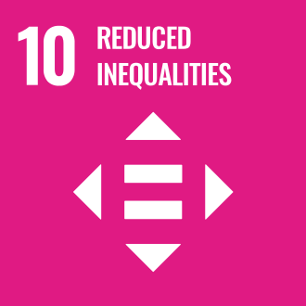 | 

Review Mechanism
- Annual Performance Review:
- An annual performance review is conducted to assess progress towards Social Responsibility goals and targets.
- Key achievements, challenges, and areas for improvement are identified through a comprehensive evaluation process.

- Continuous Improvement:
- Feedback from performance reviews, internal audits, and stakeholder engagement activities is used to identify opportunities for continuous improvement.
- Adjustments to strategies, policies, and action plans are made as necessary to enhance social performance and address emerging issues.

- Policy Review and Update:
- The Chief Social Responsibility Officer reviews this policy Every two Years to ensure alignment with changing regulatory requirements, industry best practices, and stakeholder expectations.
- Updates to the policy are communicated internally, and relevant training is provided to ensure awareness and compliance.

- Revision History

Revision No. | Revision Date | Description of Change
01 | 01-01-2024 | Initial release of the Social Policy
02 | 01-01-2025 | Modified sustainability targets with revised achievement timelines and added a formal Revision History table

(Signature)
Approved By: Mr. Ashwini Kariwala
Designations: Executive Director
Last Review Date: 01-01-2025 Next Review Date: 01-01-2027

Employee Acknowledgement Form: Social Policy

I, acknowledge that I have received, read, and understood Ganges Jute Pvt Ltd's Social Policy. I am aware of the company's commitment to fostering a socially responsible business environment, promoting ethical practices, and extending our people-centric mindset across the entire supply chain.

I understand my role in supporting this policy, including adhering to safe working conditions, fair labor practices, and ethical business conduct. I agree to contribute positively to our community engagement efforts, respect human rights, and support the company's social responsibility initiatives.

By signing below, I confirm my commitment to upholding Ganges Jute Pvt Ltd's Social Policy and supporting the company's social responsibility efforts.

Employee Name: ______________________
Date: _______________
Employee Signature: ____________________

